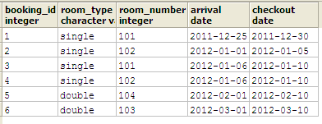
UPDATED SQL STATEMENT
SELECT
booking.id as booking_id,
room_type.room_type as room_type,
rooms.roomnum as room_number,
booking.arrival,
booking.checkout
FROM
booking, rooms, room_type
WHERE
booking.room_id = rooms.id AND rooms.room_type_id = room_type.id;

CREATE VIEW rooms_reserved AS
SELECT room_booking.room_id, room_booking.date_booking_from, room_booking.date_booking_to
FROM room_booking
WHERE room_booking.date_booking_from BETWEEN '2011-12-25'::date AND '2011-12-30'::date - 1
OR date_booking_to -1 BETWEEN '2011-12-25'::date AND '2011-12-25'::date
OR room_booking.date_booking_from < '2011-12-25'::date AND date_booking_to - 1 > '2011-12-25'::date - 1

CREATE VIEW rooms_reserved AS
SELECT room_booking.room_id, room_booking.date_booking_from, room_booking.date_booking_to
FROM room_booking
WHERE room_booking.date_booking_from IS NOT NULL AND room_booking.date_booking_to IS NOT NULL
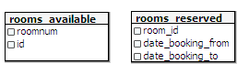
ORDER BY room_id ASC;

CREATE OR REPLACE VIEW rooms_available AS
SELECT room.roomnum, room.id
FROM room
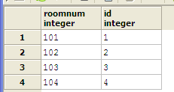
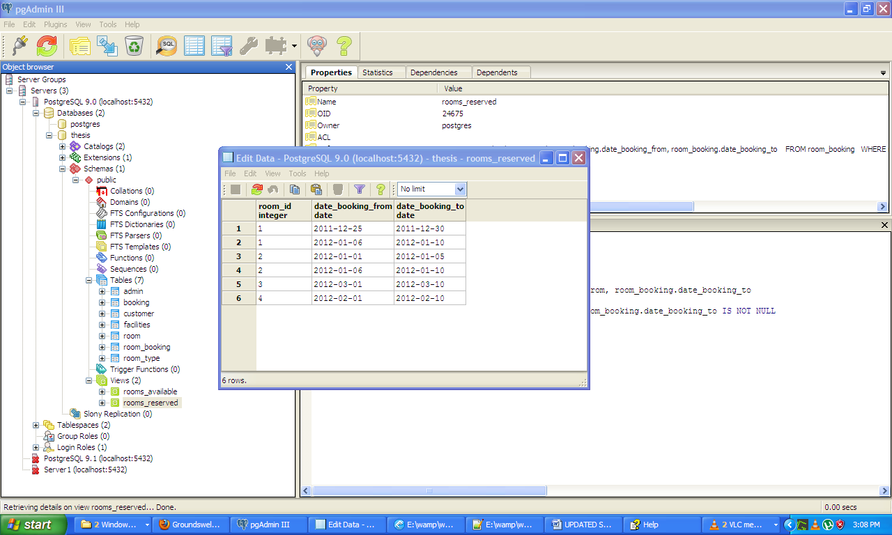
LEFT JOIN rooms_reserved ON room.roomnum = rooms_reserved.room_id
WHERE rooms_reserved.room_id IS NULL;

